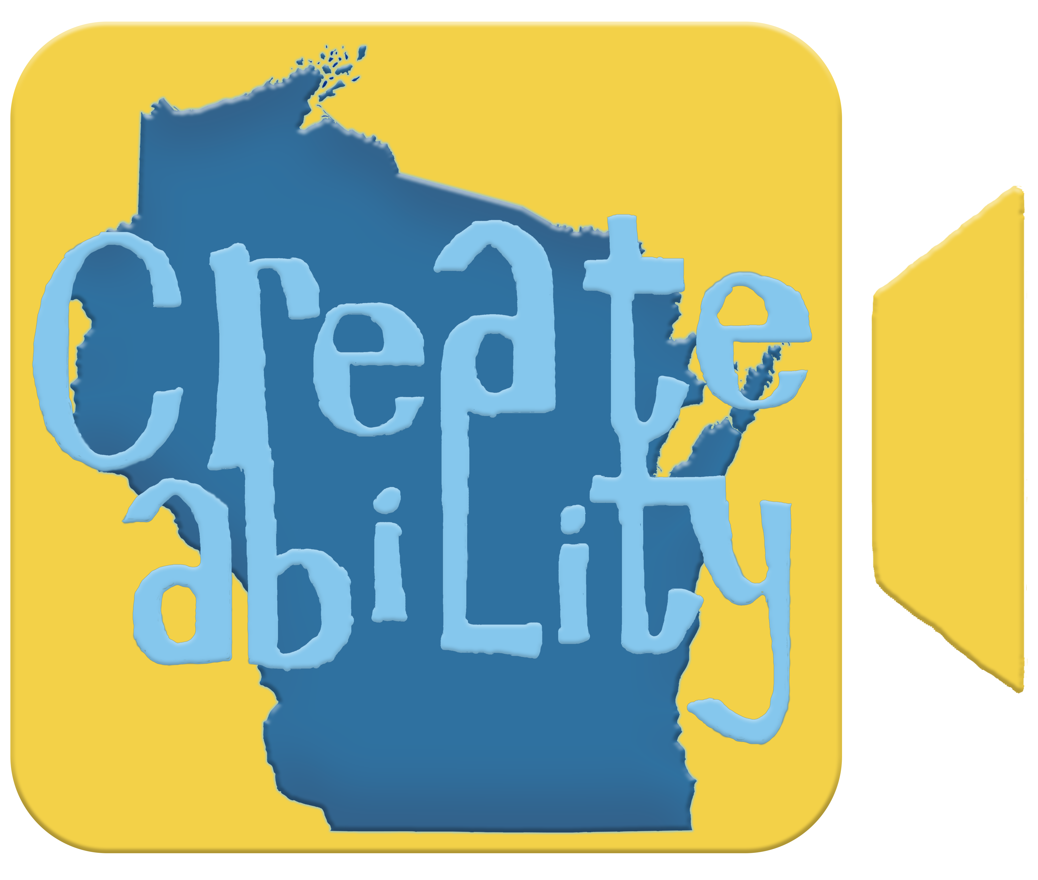

“Enable Your Creativity”

Client Intake/Referral Form

Please fill out the information in this packet to the best of your knowledge. When completed, please return to the Camp Createability office, or email it to darmstrong@createabilitywi.com
Thank You!

Participant Information

Participants Name: ________________________________________________

Date of Birth: ____________________________________________________

Preferred Name: __________________________________________________

Gender Identity: Male _____ Female _____ Other ________________

Preferred Pronouns: _______________________

Address: _________________________________________________________

City, State, Zip: __________________________________________________

Phone: _____________________________ Can we… call / text / both

Email (please print clearly): _______________________________________

Parent/Guardian/Primary Contact Information

Parent/Guardian Name: __________________________________________

Address: _________________________________________________________

City, State, Zip: __________________________________________________

Phone: _____________________________. Can we… call / text / both

Email (please print clearly): _______________________________________

Emergency Contact Person: _______________________________________

Emergency Phone Number: _______________________________________

Transportation Company (if applicable) ____________________________

__________________________________________________________________

Transportation Company Phone: __________________________________

Case Manager/Funding Information

Program Manager/Broker: _________________________________________

Organization: ____________________________________________________

Email: ___________________________________________________________

Phone: _____________________________________

Other Support Team Contacts –

Name: ___________________________________________________________

Relationship/Organization: _______________________________________

Email: ___________________________________________________________

Phone: _____________________________________

Method of Payment
We have multiple payment options available for you to pay for program services.

_____ Self Pay _____ CLTS Waiver _____ CCOP _____ IRIS

_____ My Choice _____ Community Care. ______ Other

General Information

Describe participant’s living situation (i.e. Independent Living with support, AFH, Group Home, Lives with Parent/Guardian, etc.):

How did you hear about Camp Createability? ______________________

Is the participant their own legal guardian? (Circle One) YES NO

If not, who is their legal guardian? _________________________________

If yes, to whom do we have permission to talk to on their behalf? Please list names and relationship to the participant:

Has participant had aggression towards self, others, or property within the past 12 months? (Circle One) YES NO

Is participant able to safely function without direct supervision during unstructured times? (Circle One) YES NO

Communication

When communicating information regarding Camp Createability and other information related to the participant, who should receive this information?

(Please circle all people who should receive information.)
Participant
Parent/Guardian
Care Manager
Support Team Members: __________________________________________

__________________________________________________________________

Disability & Support Needs

Primary Diagnosis: _______________________________________________

Other Diagnosis (if applicable: ____________________________________

__________________________________________________________________

Are there any physical limitations we should be aware of?

_____________________________ _____________________________________

Does the participant use any of the following?
- Wheelchair
- Walker
- Cane
- Sensory Supports
- Communication Device
- Other: ______________________________________________________

Does the participant require 1:1 support?
- No
- Sometimes
- Yes (Please explain) _________________________________________

Participant can safely:

Use the restroom independently
- Yes
- Needs reminders
- Needs assistance

Follow basic directions
- Yes
- Sometimes
- No

Behavior & Safety Information

Please circle all behaviors that apply and provide explanations of the circled behaviors.

Tantrums | Scratches | Steals
Hyperactive | Fantasizes/Hallucinates | Screams
Foul/inappropriate language | Property Destruction | Elopement/running away
Pulls Hair | Kicks | Bites
Talks to Self | Hits/Slaps/Punches | Aggressive
Depressed/Withdrawn | Attention-Seeking | Spits
Moody | Self-Harms | Head Bangs

Describe Circled Behaviors:

Describe additional behaviors or strategies that would be essential for the Camp Createability program supervisors and staff to know:

Are there any triggers for the participant, such as loud noises, change in routine, large crowds, animals, etc? (circle one) YES NO

If yes, please explain:_____________________________________________

Does the participant have a behavior plan? (circle one) YES NO

If yes, please submit a copy of participant’s behavior plan when turning in this form.

Employment & Skill Goals

Is the participant currently employed? (circle one) YES NO

If yes, where? ____________________________________________________

How many hours per week? _______________________________________

Employment Goals:
- Get a job
- Increase work hours
- Build job skills
- Social skills for work
- Creative career exploration

What skills would the participant like to improve? _________________

__________________________________________________________________

What are your employment interests? _____________________________

Creative Interests

Which programs are you most interested in?
- Art
- Mixed Media/Craft
- Animation
- Film
- Photography
- Digital Design
- Game Development
- Writing
- Theatre/Acting
- Career Exploration in Creative Fields

Interests/Hobbies:

Strengths/Abilities:

Additional Information

Does participant have any medical conditions? (circle one) YES NO

If yes, please list: _________________________________________________

Does the participant have any allergies or restrictions (dietary, animals, medications, etc.). (circle one) YES NO

If yes, please list: ________________________________________________

Are there any medical/health conditions that require care while at Camp Createability? (circle one). YES NO

If yes, please list: ________________________________________________

Are there any medication(s) that need to be taken while at Camp Createability? (circle one) YES NO

If yes, please list: _________________________________________________

__________________________________________________________________

Does participant have any emergency medical plans that Camp Createability staff should be aware of? (circle one) YES NO

If yes, please submit a copy of your participant’s emergency medical plan when turning in this form.

Is there anything else that you feel would assist us in making your creative process and visits with us more productive? Please Explain.

Permissions

I give Camp Createability permission to:
- Use photos for promotional materials
- Exhibit artwork in the studio/gallery
- Submit artwork for outside exhibitions

Signature of Parent/Guardian _____. Self _____ (Please check one)

Date: ___________________________

In case of an emergency, I understand every effort will be made to contact me or the emergency contact persons listed above. In the event that we cannot be reached, I hereby give permission to the physician listed on the form to hospitalize, secure proper treatment and to order anesthesia or surgery for the participant.

Physicians Name: _________________________________________________

Hospital Affiliation: ______________________________________________

Address: _________________________________________________________

Phone: _________________________________________

